I. Stratification

A. Definition

1. system of ranking individuals hierarchically

2. universal

3. social arrangement of structured inequality

4. determines

a. behavior, economic opportunity, educational opportunities

b. distribution of resources and benefits

c. power arrangements

5. life chances

a. infant mortality

b. health care

c. war – who goes to war? Rich or poor?

B. Two types

1. caste

a. hierarchical arrangement by birth

b. characteristics

i. rigid hierarchy

ii. ascribed status

iii. no upward mobility

iv. social interactions: complex set of norms: marriage, space, social interactions, work, education

v. severe punishment for deviance

c. examples

i. religion: India

ii. race: South Africa

iii. ethnicity: Rwanda

iv. gender: Afghanistan, Saudi Arabia

2. class

a. social organization based on economic rank

b. characteristics

i. hierarchy

ii. social mobility

iii. achieved status

iv. meritocracy – rank is based on achievement

v. achievement norms

work ethic

education

attitude – how far does a positive attitude get you?

II. Stratification in U.S.

A. Class system

B. Conventional Wisdom

1. those at the top are deserving (because of meritocracy?)

2. equality of opportunity

a. achieved status

b. upward mobility

3. society: meritocracy

a. education

b. work

4. poor

a. not really poor

b. “have it too good”

c. no effort, not willing to work

d. need to cut programs

e. Social Darwinism (survival of the fittest – if you ain’t fit, you lose)

5. Structural Functionalism: Davis Moore Theory

a. universal

b. necessary

c. positive

B. Inequality in America (Mother Jones: It’s the Inequality Stupid)

- Wealth

Figure 4: The actual United States wealth distribution plotted against the estimated and ideal distributions.
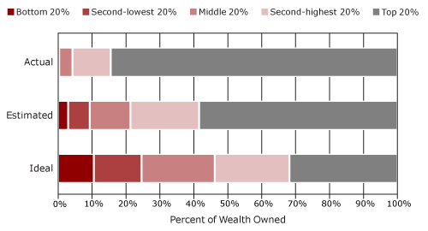

a. concentration

b. patterns

i. historically

ii. comparison

http://www.youtube.com/watch?v=slTF_XXoKAQ

2. Income

a. concentration

b. patterns

c. comparisons

3. upward mobility?

a. since 1970s: little or no intergenerational upward mobility

b. comparatively : lower social mobility for poor: Canada, Britain, Germany and France

c. education as a “gatekeeper”

i. tracking and IQ testing

ii. higher education and cost

4. poverty

a. definition

b. measuring

c. by the numbers

i. 2008 12% or 40 million

ii.2012 16% 50 million

d. by the numbers children

i. 2008 19% 12.8 million

ii. 2011 22% 16.4 million

e. by the numbers: race

i. African American and Hispanic Americas: 25%

ii. White Americans: 10%

iii. AA children 50% (up from 34%)

f. severely poor (20 million 2x since 1979)

g. working poor

h. generosity for the poor?

i. Welfare reform TANF (Personal Responsibility and Work Opportunity Conciliation Act)

ii. less than ½ of poor families receive TANF benefits/
iii. avg $372

iv. children 1.8 (30% receive benefits)

v. cut food stamps

i. who benefits?

i. surplus of desperate workers that depress wages.

ii. someone to do the dirty and dangerous work in
society

iii. creates jobs to maintain the social order ( power arrangements): police, social workers, prison guards

iv. profit: “poverty surcharge” on food: +8%-18%

v. profit: rip off loans

vi. scapegoats for wealthy, someone to blame

